EXPERIMENT NUMBER: 6
AIM OF THE EXPERIMENT: To study about the construction and operation of pneumatic control valve.
OBJECTIVE:
- To study the construction of single seat pneumatic control valve.
- To study the operation of single seat pneumatic control valve.
THEORY:
The different parts of the single seat pneumatic control valve are given as per the figure.
- Seat – It is where the plug sits or rests.
- Packing – It is necessary to make the movement of the stem vertical.
- Plug – It is that component which can close or open the valve by its movement. In the given valve, when the plug sits on the seat then it is fully closed. The shape of the plug can be different.
- Bonnet – It contains the packing box and stem seat and can guide the stem.
- Cage – It is the part which surrounds the plug and seat.
- Diaphragm – It is a flexible, pressure responsive element that transmits force to the stem and it is at the top of the control valve.
- Port – It is the opening through which the valve fluid will flow in and flow out of the valve.
OPERATION: The pneumatic valve is an air-operated valve, which controls the flow through an orifice by positioning a plug appropriately. The plug is attached at the end of a stem which is supported on a diaphragm at the other end. As the air pressure (controller output) above the diaphragm increases, the stem moves down and consequently the plug restricts the flow through the orifice.
FAIL OPEN:
In air-to-close pneumatic valve, if the air supply above the diaphragm is lost, the valve will fail open since the spring would push the stem and the plug upward, as shown in figure.
FAIL CLOSED:
A valve condition in which the valve closer member moves to the closed position when the actuating energy source fails. In case of pneumatic valve where the actuating signal condition is air-to-open. If the air supply below the diaphragm is lost the valve will ‘fail close’ since the steam would push the plug downwards.

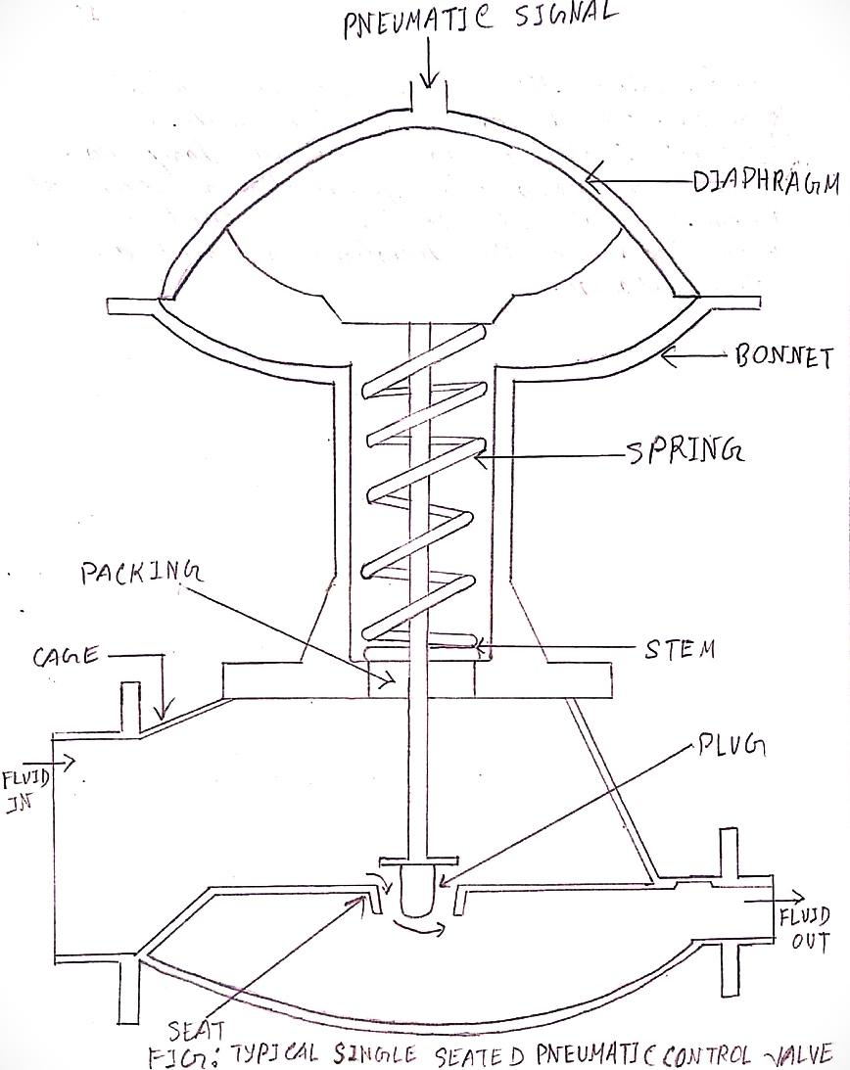
Figure: TYPICAL SINGLE SEATED PNEUMATIC CONTROL VALVE

