**EXPERIMENT NUMBER: 5**

**AIM OF THE EXPERIMENT:** To study about the derivative control.

**THEORY:**  In this type of controller actuating output signal ‘y’ is proportional to the derivative of error signal (dx/dt) or the control action is proportional to the rate of change of a controlled variable.

Referring to the fig. if ’x’ is where to rise the piston will more down with a velocity producing a force proportional to it due to the shearing action in the viscous oil. Since the cylinder is mounted on springs, the spring deflection ‘y’ is proportional to the force developed and transmitted through the oil. So we write:

**y ∝ dx/dt**

**Or y = k2 Dx**

Where **, k2****Constant**

**D****d/dt**

In this type of control, the controller output is more if the rate of change of ‘x’ is more, if ‘x’ were constant or the float stopped at any position away from the set point , the position as stopped and the springs would restore the cylinder to its initial position . The derivatives control helps in transient state increases the overall damping. It is used along with proportional control action so that the controller output is proportional to the deviation as well as its rate of change.

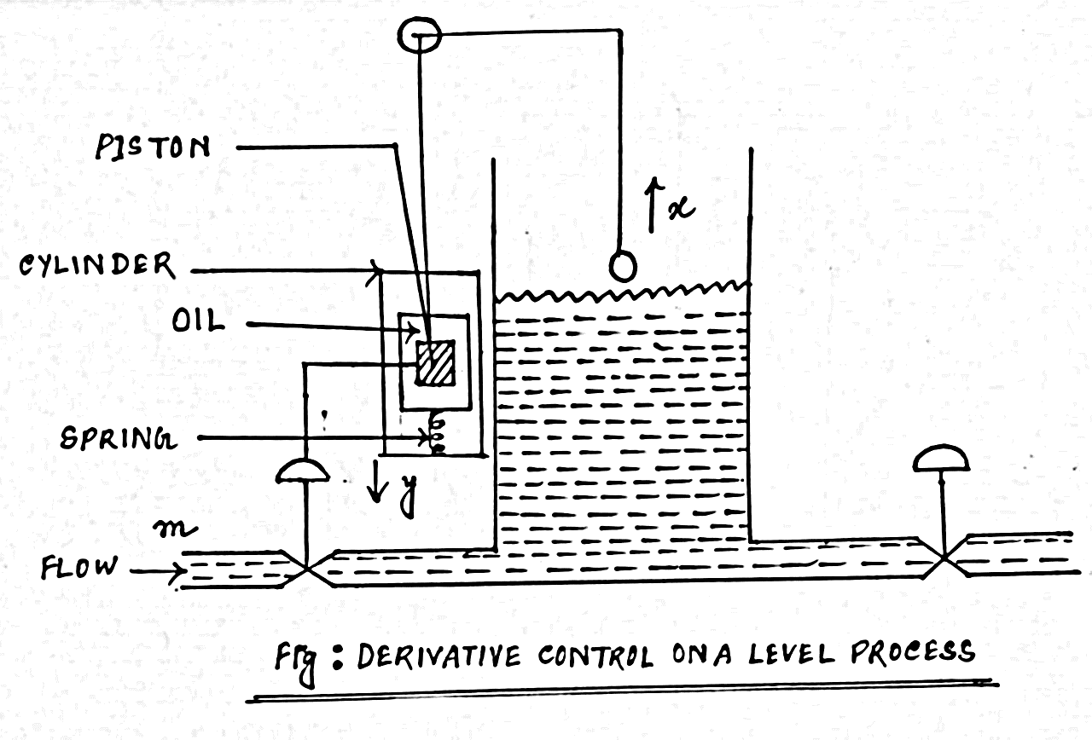

Fig : Derivative Control on a Level Process