EXPERIMENT NUMBER: 4
AIM OF THE EXPERIMENT: To study about the “INTEGRAL CONTROLLER”.
THEORY: Integral action is a mode of control action in which the value of the manipulated variable ‘m’ is change at a rate proportional to the deviation is doubled over a previous value; the final control element is moved twice as fast. When the controlled variable is at the set point (zero deviation), the final control element remains stationary.
Integral control is illustrated in previous fig. A set point mechanism is emitted in the drawing. A variable ratio speed reducer consisting of two parallel disks with a friction drive roller between operates a control value through gears. The left hand disk is driven at a constant speed by an electric or other motion. The position of the friction drive roller is set by the float and arm, the controller action is as follows; a rise in level in a tank causes a drive roller to move up from the neutral point (zero speed).
The speed of motion of the valve stem is proportional to the change in the level moves the drive roller below the neutral point and the valve is moved at a proportional speed in the opposite direction.
Integral control follows the law-
m = 1/Ti.e equ.1
OR
m= 1/Ti∫edt + M equ.2
where, m→manipulated variable
Ti→integral time
e→deviation of integration
The integral time Ti is defined as the time of change of manipulated variable caused by a unit of change of deviation.
For a step change of deviation –
e =0 , t < 0
e =E, t ≥ 0
where, E is a constant , then from equation (2)
m = 1/Ti ∫Edt + M
m = E/Ti.t + M
Thus the manipulated variable changes linearly with time and ̔integral ̓ the area under the straight line. For a step change of deviation E=1 ,the step is inverse , of integral time (1/Ti). Integral control is also called reset control or proportional floating made control.

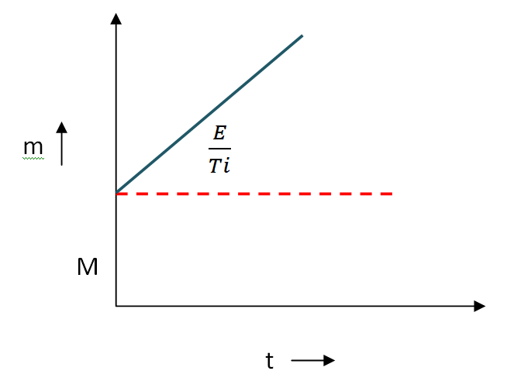

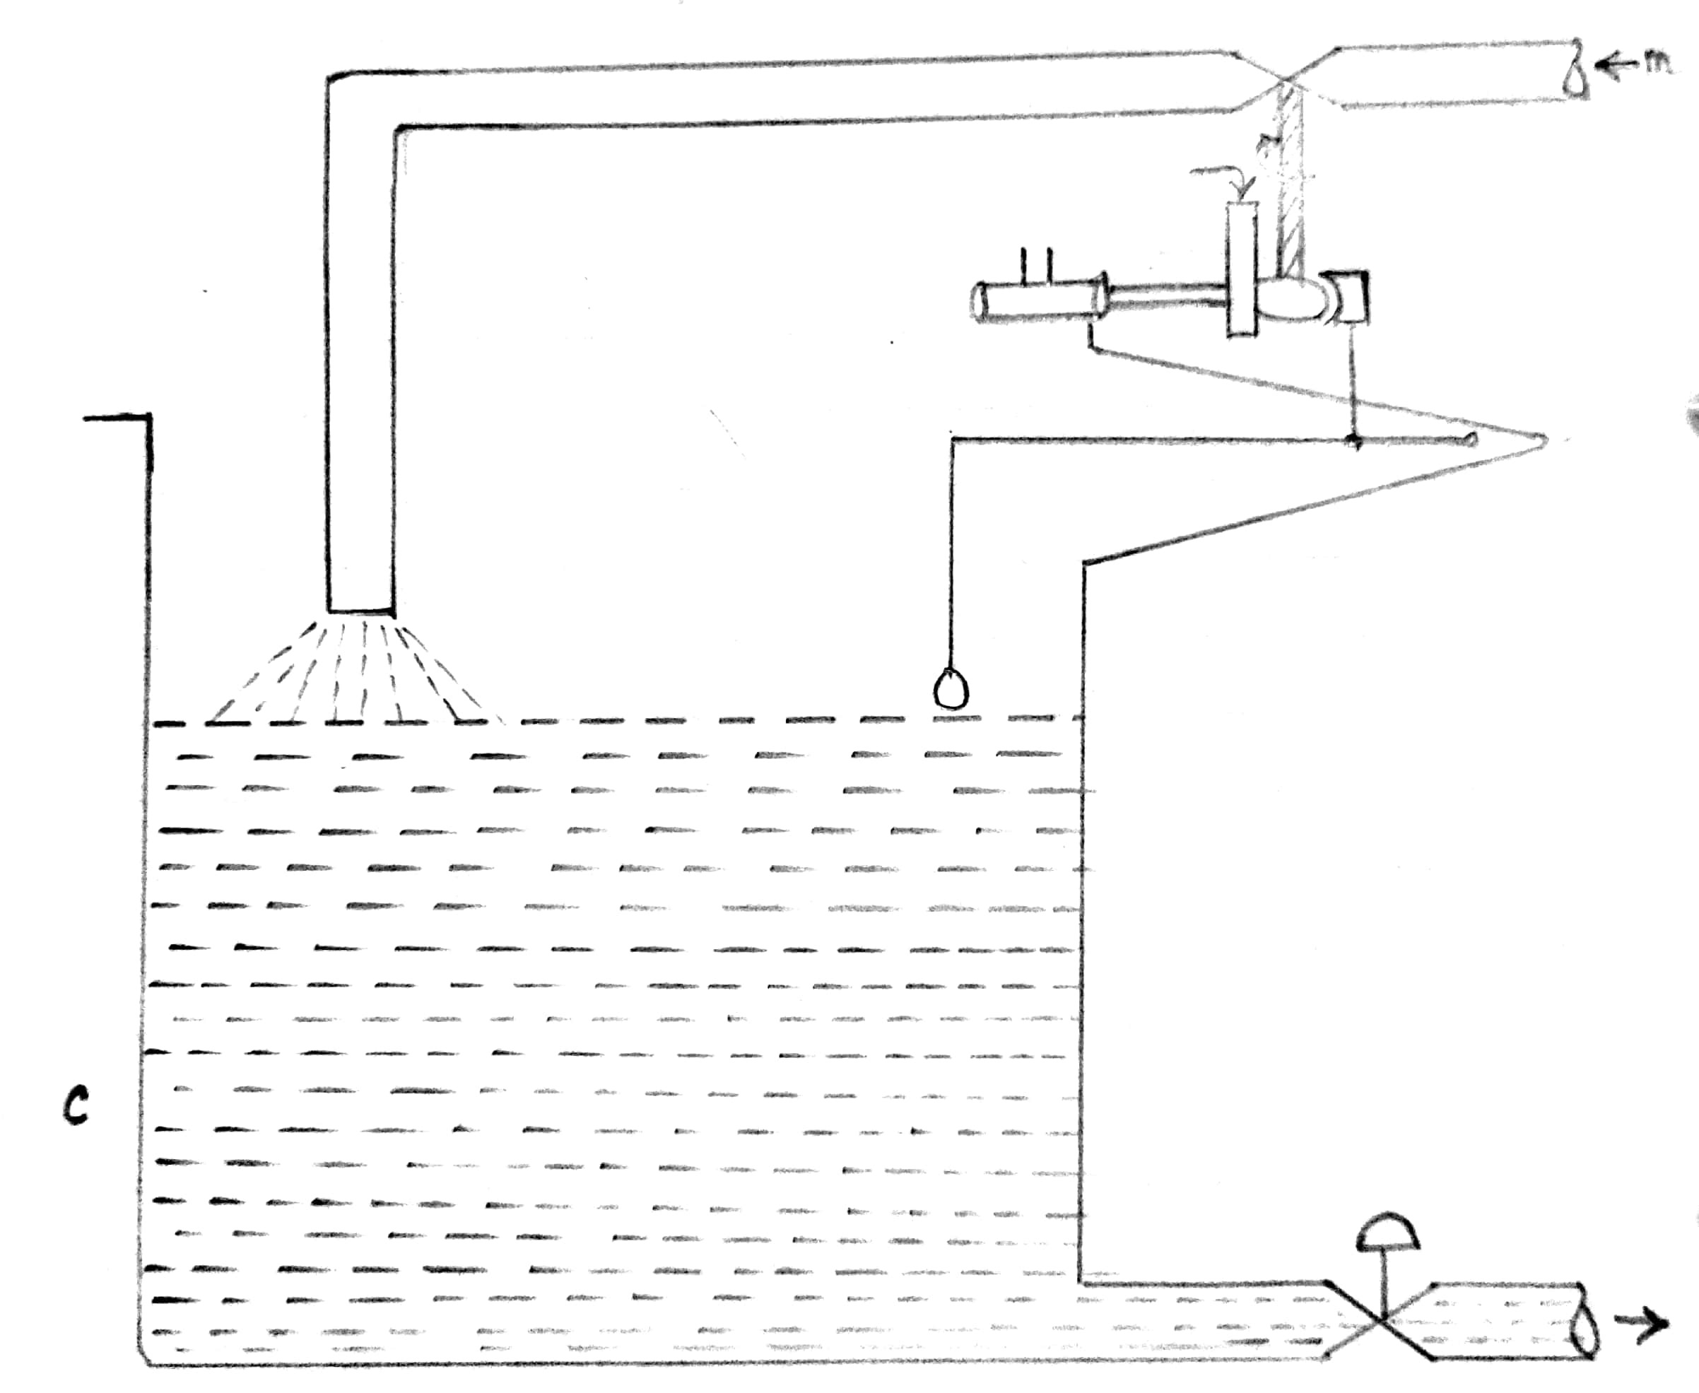

Fig : Integral Control on a Level Process

