**EXPERIMENT NUMBER: 3**

**Aim of the experiment:** To study about the “proportional controller”.

**Theory:**

A proportional (P) action is a mode of control action which continuously adjusts the manipulated variable so that the input to the process is approximately in balanced with the process demand. In proportional control, the output of the controller is proportional to the error.

The proportional type of control action is applied to a level control process. The controlled variable is the level of the liquid in the tank ‘x’ represents the change in the level or the error in level and ‘y’ represents the movement of the controlled valve. If the level tends to change from the set point i.e. if it increase as shown in the figure given due to the liver. ‘y’ will be downwards i.e. the valve closes the inflow, “q in” reduces and thus the level is maintained at the set point or till steady state is reached.

Thus

y ∞ x

or y = kx

k is being the proportionality constant

Taking the previous motion, the proportional control follows the law,  
  
 m α e  
 or, m = Kc .e

where, m manipulated variable  
 e error or deviation  
 Kc proportional sensitivity

The proportional sensitivity (Kc) is the change of manipulated variable cause by the unit change of deviation. The proportional band is equivalent to the increase of proportional sensitivity. If the controller has a scale showing the value of the controlled variable, the proportional band is percentage of full scale change of the controlled variable required to operate the valve through full stroke.

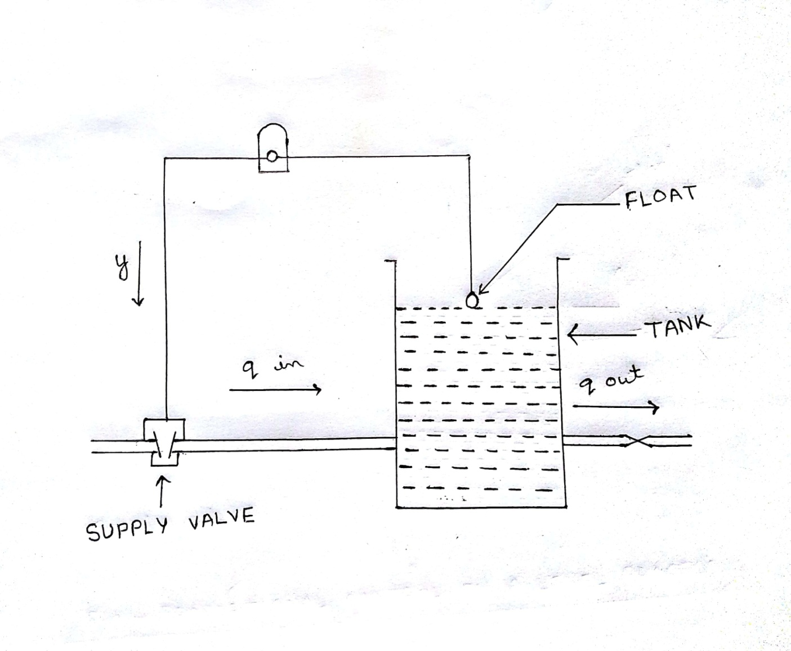  
  
**FIG : PROPORTIONAL CONTROL ON A LEVEL PROCESS**

m 

e