EXPERIMENT NUMBER: 2
AIM OF THE EXPERIMENT: To study the closed loop control with the example of home heating system.
THEORY: Automatic control is the maintenance of a desired value of a quality or condition by measuring the existing value, comparing it to the desired value and employing the difference to initial action for reducing this difference. Thus automatic control required a closed loop of action and reaction operating without human aid.
To illustrate the closed loop action, we consider the example of the control used in a home heating system as shown in the figure. Suppose it is desired to maintain the temperature of a home at 21℃. This temperature is the desired value of set point. A thermometer is installed in the inside wall of the home and measure the existing room temperature. This temperature is the control variable. A person watching the thermometer notes that temperature is 18℃, which is less than the desired value. The difference in 3℃ which is the deviation and an actuating signal is generated. An action is then taken to reduce this difference by operating a switch or valve that turn on the fuel gas to the furnace burner. The flow of the fuel gas is the manipulated variable as the furnace heat, warm air is delivered to the room and temperature will increase. In a short time the temperature becomes too high and the whole sequence must be repeated in the opposite direction.
The control action is characterized by the closed loop from control variable to deviation to manipulated variable. Then again to control variable as illustrated in the given figure.
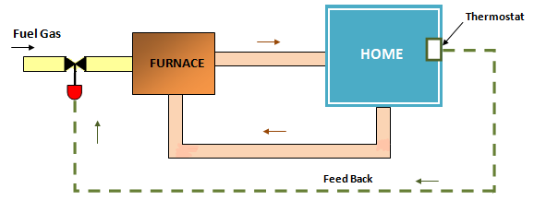
Fig: Home Heating System.

